Course Name: | Elements of Electrical and Electronics Engineering | Semester: | I
Date of Performance: | 14 /10 / 2022 | Batch No: | C3-3
Faculty Name: | Annu Abraham | Roll No: | 16010122221
Faculty Sign & Date: |  | Grade/Marks: | / 25

Experiment No: 2

Title: Battery Voltage level Indicator.

Aim and Objective of the Experiment:
- To understand voltage division concept, current division concept and principle of operation of LED.
- To develop a micro project (Battery level indicator) based on the concepts learned in the form of various task performed in the experiment.

COs to be achieved:
CO1: Analyze resistive networks excited by DC sources using various network theorems.
.

Circuit Diagram/ Block Diagram:
Task 1: Voltage division Concept and its verification on breadboard

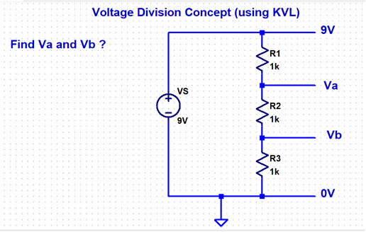

Task 2: Current division Concept

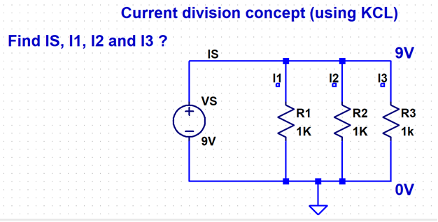

Task 3: Turn on an LED and measure its turn-on voltage

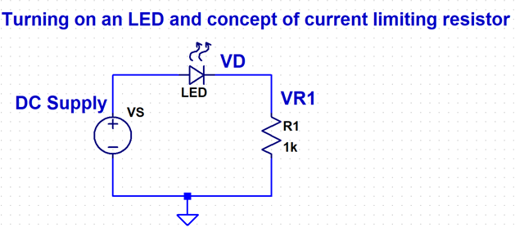

Task 4: Battery Level Indicator Circuit

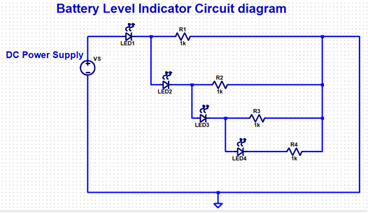

Stepwise-Procedure:
1. Make the connections as shown in the circuit diagram for Task1. Measure the voltages Va, Vb
and current Is for Task 1 and compare with calculated results.
2. Make the connections as shown in the circuit diagram for Task2. Measure the currents I1,I2, I3
and IS and compare with calculated results.
3. Make the connections as shown in the circuit diagram for Task3. Measure the voltages VS, VD,
VR1 for Case1 and Case 2.
4. Make the connections as shown in the circuit diagram for Task4. Measure the voltages across
LED and resistors.

Observation Table:
Observation Table 1 ( Task 1)
Voltages / Currents | Theoretical reading | Practical reading
Va | 7.6 | 7.5
Vb | 4.5 | 4.6
Vc | 1.4 | 1.4

Calulations (Task1):

Calclaute Va and Vb using the formula given below:

=(5.5*9)/6.5=7.6 V
=(3.3*9)/6.5=4.5 V
=9/6.5=1.38 A

Observation Table 2
Currents | Theoretical reading ( I mA) | Practical Reading (I mA)
I1 | 9 | 9
I2 | 9 | 9
I3 | 9 | 9
IS | 27 | 27

Calculations (Task2):

Calculate I1, I2, I3 and IS using the formula given below:

Observation (Task 3):
Case 1 : LED just turn’s ON

Parameters | Practical reading
VS | 1.8
VD | 1.7
VR1 | 0.16

Case 2 : LED turn’s ON ( glows brightly)

Parameters | Practical reading
VS | 9
VD | 1.9
VR1 | 6.9

Observations (Task4):
Case 1 : Supply Voltage Levels recording

Scenario | DC Supply voltage (VS) reading
LED 1 ON | 2.2
LED 1 ON & LED 2 ON | 4
LED 1 ON & LED 2 ON &  LED 3 ON | 5.7
ALL LEDs ON | 8.3
Case Case 2: Status of voltages in the circuit

Voltages | Practical reading (in Volts)
VLED 1 | 2.02
VLED 2 | 1.94
VLED 3 | 1.86
VLED 4 | 1.75
VR1 | 6
VR2 | 4.05
VR3 | 2.2
VR4 | 0.4
Screenshot of Output:

Post Lab Subjective/Objective type Questions:
- Mention some applications of battery level indicator.
Ans. A battery indicator is a device which gives information about a battery. This will usually be a visual indication of the battery's state of charge. Some of its applications are battery indicators in power banks, wireless earphones , laptops and many other battery appliances.

- Explain practical usage of Voltage- division concept?
Ans. A voltage divider can be used to scale down a very high voltage so that it can be measured by a volt meter. The high voltage is applied across the divider, and the divider output—which outputs a lower voltage that is within the meter's input range—is measured by the meter.

- Explain working of Battery Level Indicator implemented in this experiment in your own words?
Ans. We used the concept of Voltage division wherein we have connected the resistors in parallel to each other so that the leds connected next to it only lights up when the battery is above a particular voltage. Battery level indicator lets us know the status of battery of a device just by glowing the number of LEDs. The voltage probe helps us to know the voltage difference values at which the LEDs glow dimply and brightly. Using this we can determine the status of the battery

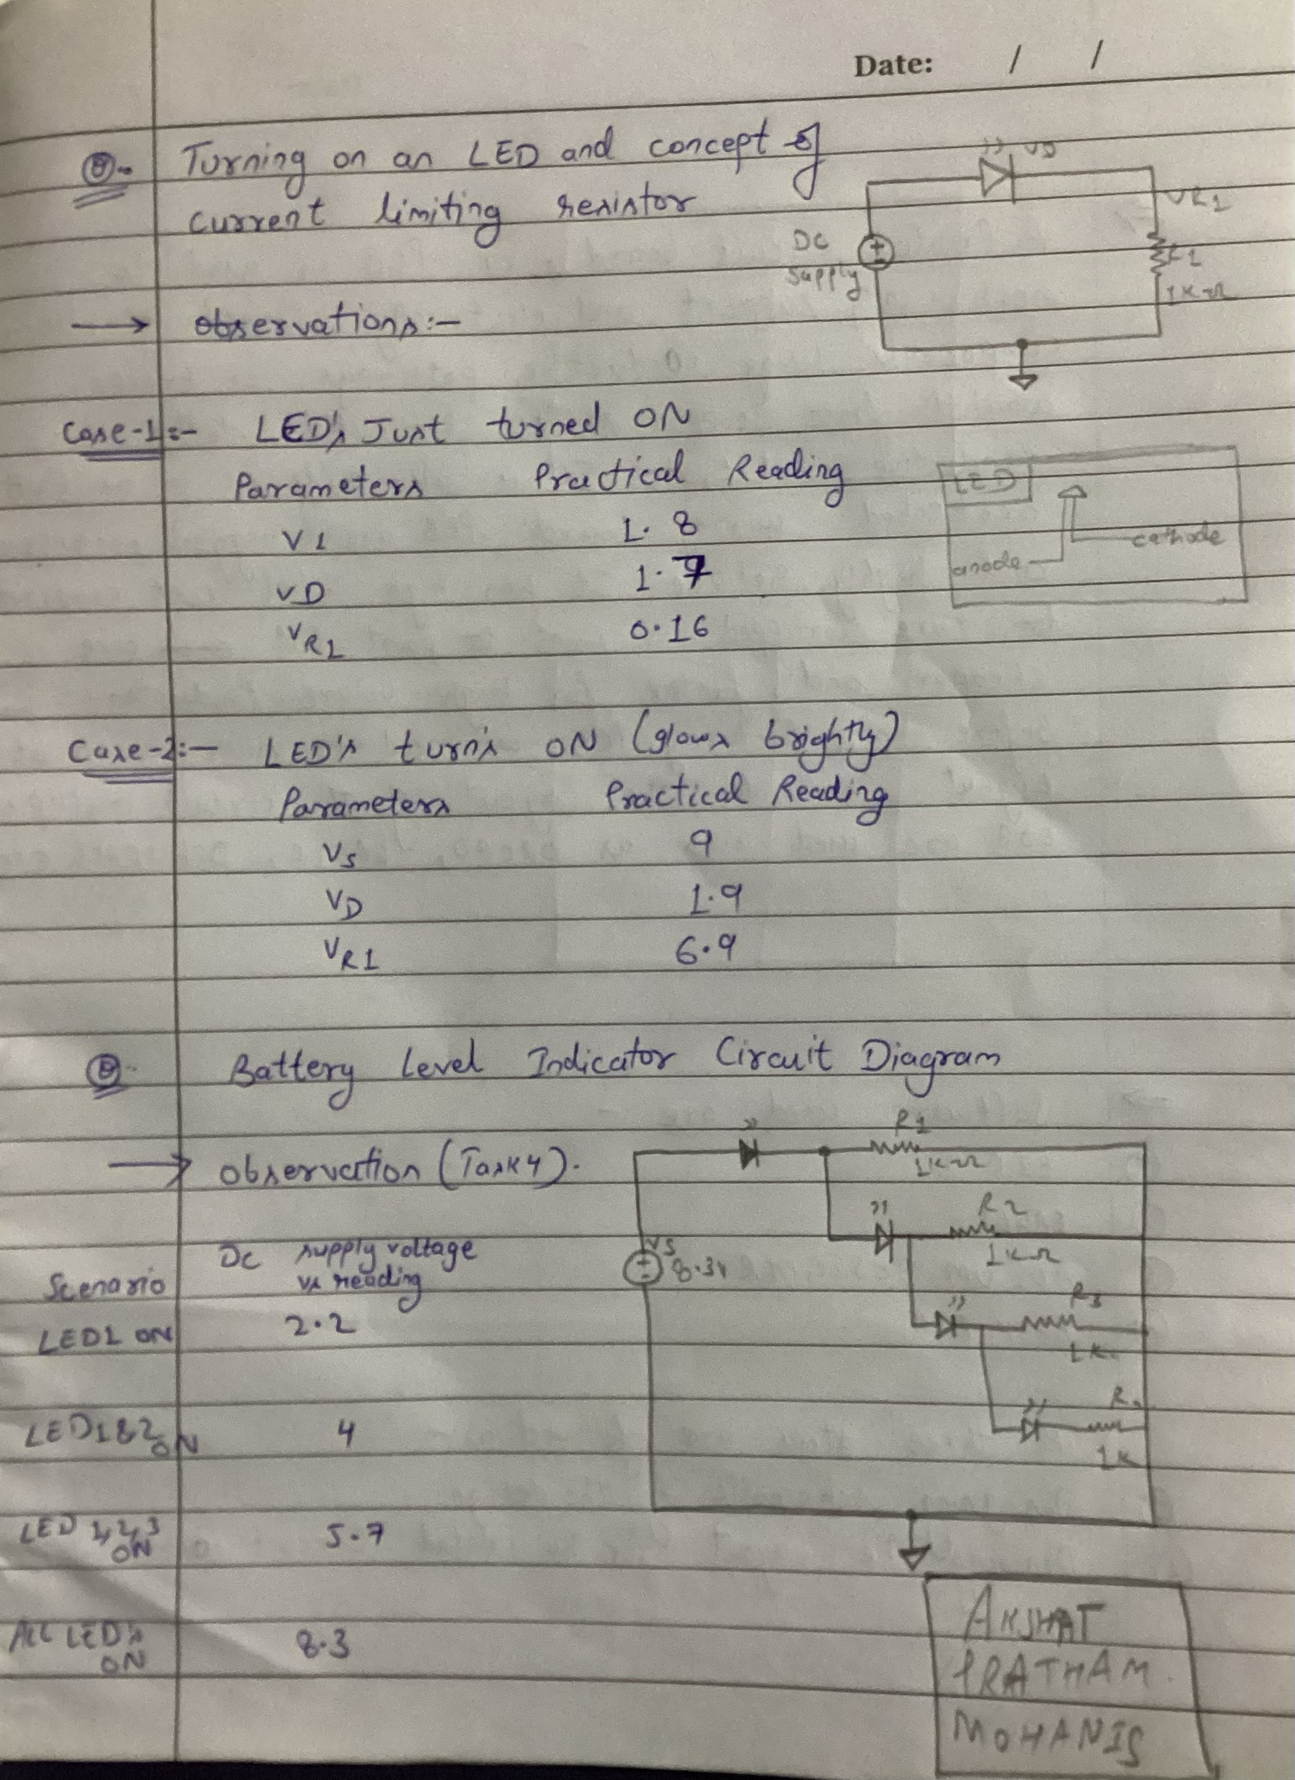

Conclusion:

In this experiment we learnt the uses and applications of battery level indicator and voltage division.

Signature of faculty in-charge with Date:

